|  |  |  |  |
| --- | --- | --- | --- |
| **SVKM's-IOT, Dhule**Shri Vile Parle Kelavani Mandal's  **INSTITUTE OF TECHNOLOGY**  **DHULE (M.S.)**  **DEPARMENT OF COMPUTER ENGINEERING** | | | |
| **Subject :** Java Programming Lab (Seminar-I) | | | Remark |
| **Name :**  Ansari Asharul Ameen Naeem Ahmad | | **Roll No. :** 63 |
| **Class:** SY. Comp. Engg. | **Batch : S4** | **Division: A** |
| **Expt. No. :**05 | **Date : 09/09/2024** | | Signature |
| **Title :**  Write Java Programs on dealing with Arrays. | | |
|  | | |
|  | | |

**//program 1 :**

import java.util.Scanner ;

class array {

public static void main(String[]args){

Scanner sc = new Scanner (System.in);

int x [] = new int [5];

System.out.println("Enter the values for array");

for(int i=0;i<5;i++){

x[i] = sc.nextInt();

}

System .out.println("----------------------");

for (int i =0;i<5;i++){

System.out.println(x[i]);

}

}

}

// output

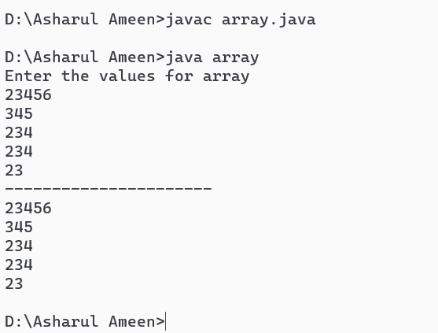

**// program 2:**

import java.util.Scanner ;

class arr2{

public static void main(String[]args){

int x [][] = new int [3][3];

Scanner sc = new Scanner (System.in);

System.out.println("Enter the value for the matrix");

for(int i=0;i<3;i++){

for(int j =0;j<3;j++){

x[i][j]= sc.nextInt();

}

}

for (int i=0;i<3;i++){

for(int j=0;j<3;j++){

System.out.println( x[i][j] +" \t");

}

System.out.println(" ");

}

}

}

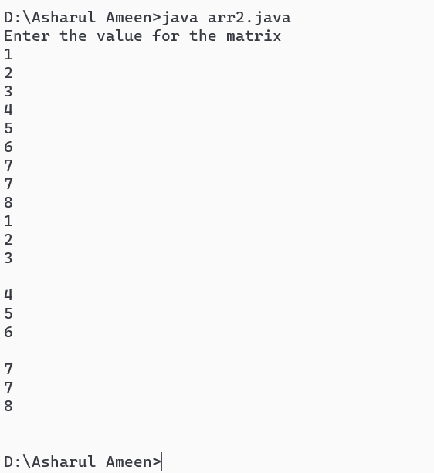

// output

// program 3:

import java.util.Scanner ;

class array3 {

public static void main(String[]args){

Scanner sc = new Scanner (System.in);

int x [][]=new int [2][2];

int y [][] = new int [2][2];

int add [][] = new int [2][2];

System.out.println("Insert the elements");

for (int i=0;i<2;i++){

for (int j=0;j<2;j++){

x[i][j] = sc.nextInt();

}

}

for (int i=0;i<2;i++){

for (int j=0;j<2;j++){

y[i][j] = sc.nextInt();

}

}

for (int i=0;i<2;i++){

for (int j=0;j<2;j++){

add [i][j] = x[i][j]+y[i][j];

}

}

System.out.println ("addition of the martrix is");

for (int i=0;i<2;i++){

for (int j=0;j<2;j++){

System.out.println (add [i][j]+"\t");

}

System.out.println(" ");

}

}

}

// Output

